**Adding additional storage in EC2 [AWS]**

Q.I have an instance with 8G storage, I want to create a directory for user 1 and allocate him 6G and another user 6G. So, the users shouldn’t have to worry about the space, minimum they should have the requested size in their working directory. How can u complete this task

A:

1. we want an instance with 8 G of basic storage

2. we will attach total of 12G disk

3. Then we need to split the 12G into 2

* first attach the 12G EBS then partition it into 2 one 6G and 6G

then attach another EBS for the 2G space needed for Dockerstorage

* Need to make sure the users have their home directory with the size requested and the users should be isolated
* Create IAM user account for the user and give access to ec2 machine
* Each user should login to their respective home directory using SSH key pair authentication method  
    
    
  Phase 1:

Attached the 12G of volume   
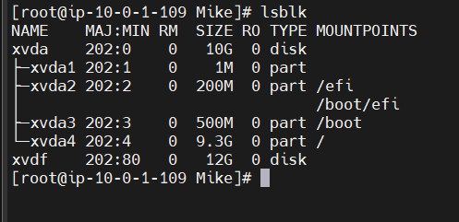

will partition it into 2 , each having 6G of storage  
  
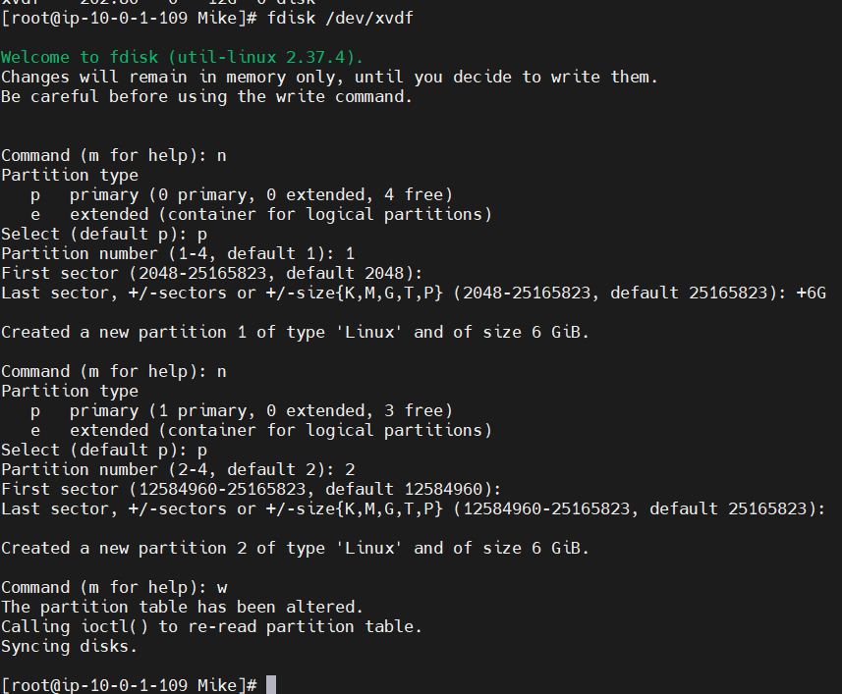

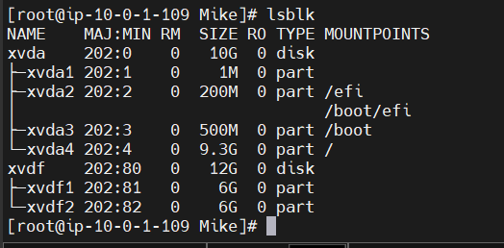

Now we will make the both disks as physical volumes

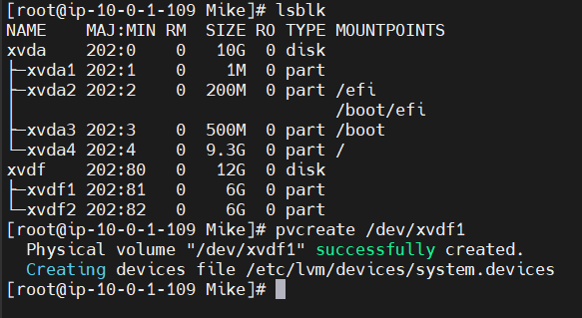

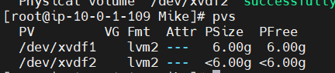

Now we will create a volume group

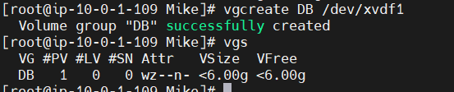

Now we will add other pv to vg

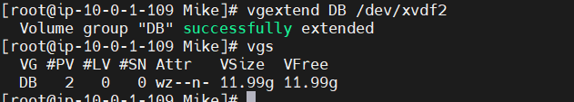

Now we will make logical volumes for new user Kiran in root /Kiran and Ted in /Ted, each having 6G storage

logical volume kiranlv of 6G is created by taking the storage from volume group DB for Kiran

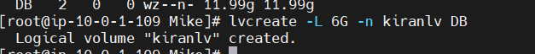

similarly, logical volume tedlv of 6G is created by taking the storage from volume group DB for ted

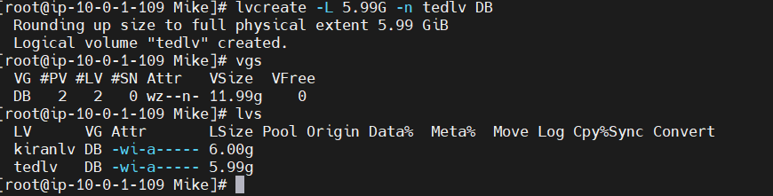

Now we will mount the storage at /ted and /kiran

before:

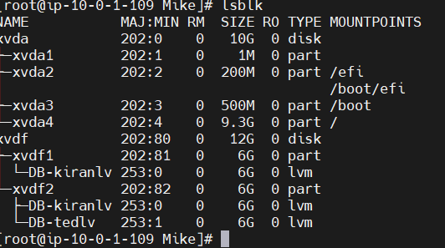

before mounting we need to format the filesystem of logical volume

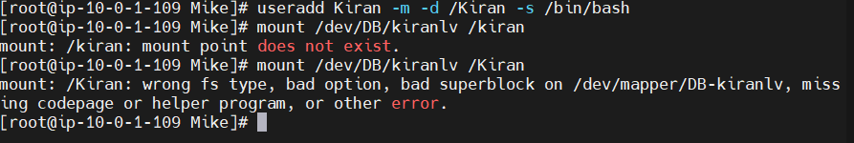

after:

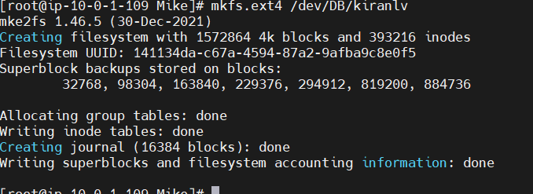

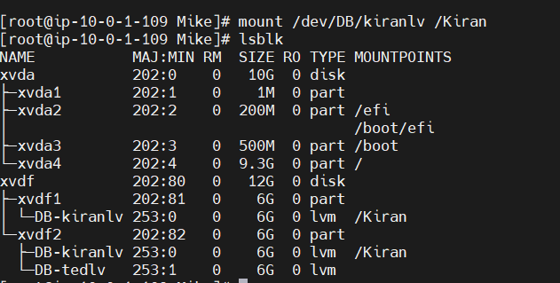

Similarly , we have mounted for Ted

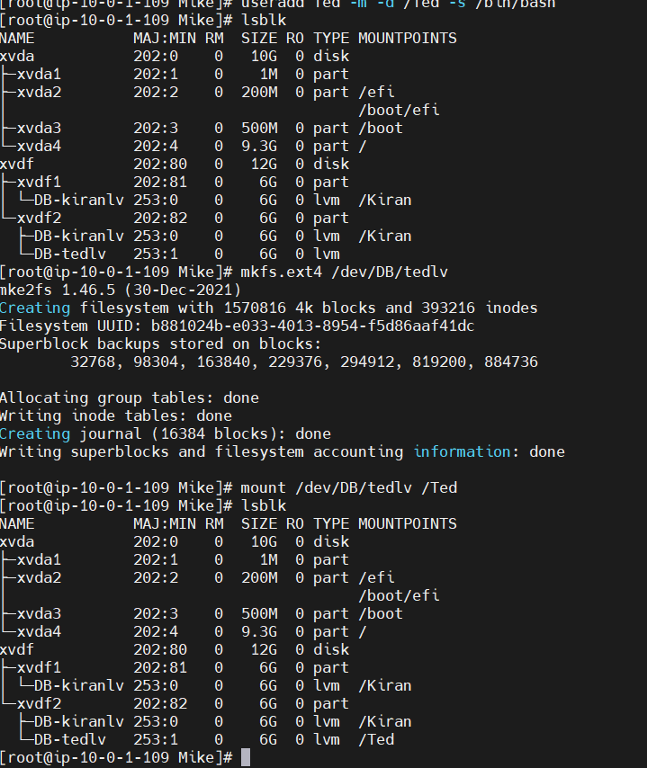

Mike have requested an addition of 2G storage for storing the large files but we don’t have any other space left in VG to give   
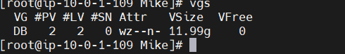

Now we will add another 2G volume for Mike to store the large files in /Home/Mike/Backup

we have attached another 2G of volume   
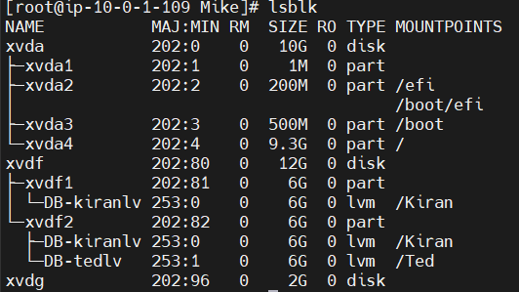

Now we will do the similar process for creation of partition and PV

while partitioning we have used entire storage this time

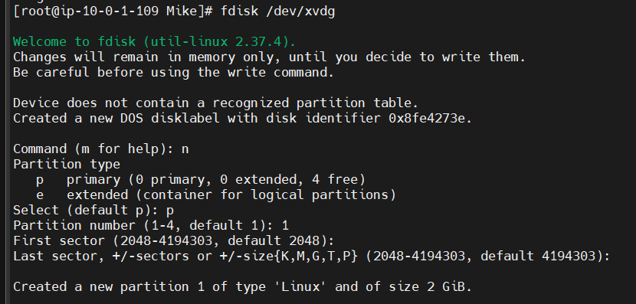 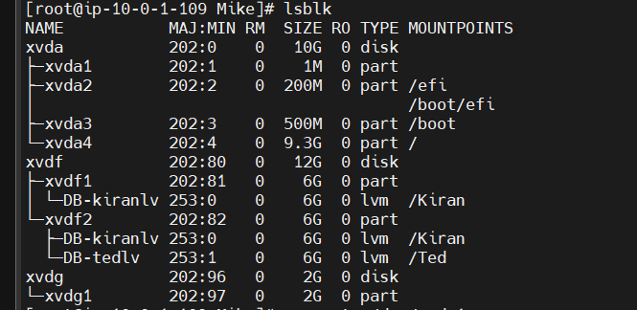

PV created



We extended the volume of existing VG named DB



Now VG have free space of 2G

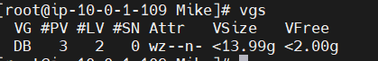

Now we will mount 2G volume for Mike to store the large files in /Home/Mike/Backup

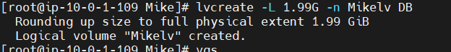

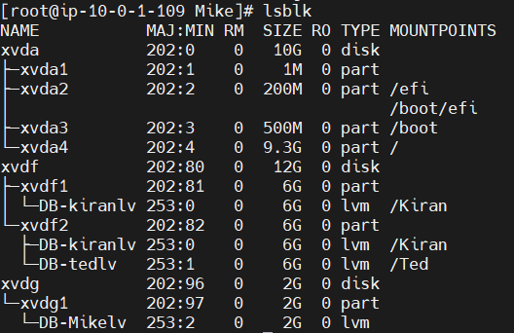

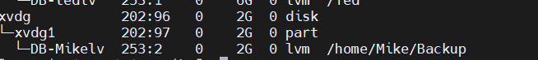

df -h will give all the storage details

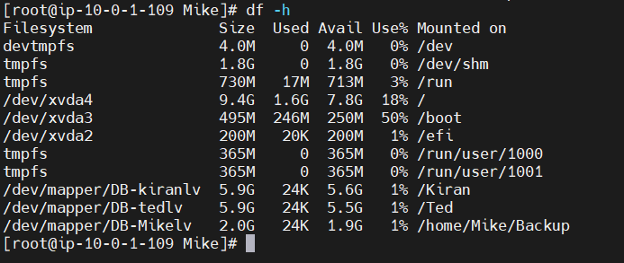  
  
To make any of the storage as permanent   
edit fstab file using vi /etc/fstab

then copy the path of the mounting point the update all details  
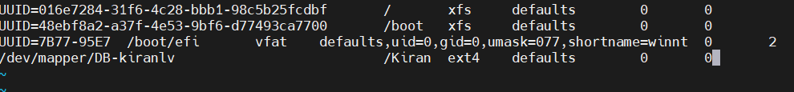  
  
Now we have successfully shared the storage space across the users need by attaching additional volume.

Now we will completely remove the storage that have attached

for that we need to do it in reverse order

1.unmount the storage

2.remove the LVs

3.remove the VGs

4.remove the EBS storage